33818390

Prabhpreet kaur

DR. V.L raju chinthalpati

**AI AND MACHINE LEARNING APPLICATIONS IN FINTECH/REGTECH**

**Acknowledgement**

It is my sincere pleasure to thank all those people who have encouraged me and helped me to conduct this research. In the first place, I want to express my gratitude to the supervisor and provide heartfelt thanks for the exceptional support and helpful recommendations. It is their support and motivation that helped to develop this research and bring it to the latter stage. I also want to thank the faculty and staff of my institution for creating an environment suitable for learning and research. The resources and facilities at my disposal helped me a lot in the outcome of this study. I will also thank my colleagues and peers for their critical views and contributions towards the development of this research. They became friends and their views as well as companionship offered academic and social assistance. It is my family and friends' grace and support for the entire duration of the process that I am grateful for. The confidence they have put in me has been a great motivation. Therefore, I would also like to express my gratitude to all those, who are not directly involved in the process of the present research.

**Abstract**

This study seeks to include AI and ML in the FinTechs and RegTechs to strengthen compliance with the upcoming regulations and financial stability.

Chapter One gives an overview of the research background, pointing to the increasing difficulties due to the day-to-day changes in the conditions for compliance with regulations in the framework of the digital economy. It provides the background of a growing concern in comprehensiveness and cost of regulations and then goes on to present AI/ML as possible solutions.

Chapter two presents an analysis of the existing gaps in the traditional systems and the development of advanced AI/ML models in the FinTech and RegTech fields.

Chapter 3 outlines the methodology used, including the selection of models (DistilBERT, Logistic Regression, SVM) and the experimental design for text classification tasks, which are crucial in regulatory compliance.

Chapter 4 presents the findings, showing that DistilBERT outperforms traditional models in accuracy and contextual understanding, aligning with recent studies that emphasize the effectiveness of transformer models.

Chapter 5 links these findings to the research objectives, providing recommendations for adopting AI/ML technologies in regulatory processes.

Chapter 6 concludes the research by discussing its implications, offering recommendations, and suggesting future research directions to further enhance compliance in FinTech using AI/ML.

**Table of Contents**

Chapter 1: Introduction 5

1.1 Introduction 5

1.2 Research Background 5

1.4 Aims and Objectives 7

1.5 Research Question 7

1.6 Research Significance 8

1.7 Summary 8

Chapter 2: Literature Review 9

2.1 Introduction 9

2.2 AI/ML in FinTech 9

2.3 AI/ML in RegTech 10

2.4 Benefits of AI/ML in FinTech/RegTech 10

2.5 Challenges and Risks 11

2.6 Comparison with Traditional Methods 11

2.7 The Role of Big Data 12

2.8 Emerging Trends and Technologies 12

2.9 Regulatory Perspectives 13

2.10 Literature Gap 14

2.11 Summary 14

Chapter 3: Methodology 16

3.1 Introduction 16

3.2 Research Methods 16

3.3 Research Philosophy (Realism) 16

3.4 Research Approach 17

3.5 Research Design (Experimental) 17

3.6 Data Collection Method (Secondary) 18

3.7 Tools and Techniques 18

3.8 Ethical Considerations 19

3.9 Summary 19

Chapter 4: Findings and Analysis 20

Chapter 5: Results and Discussion 22

Chapter 6: Conclusion 31

6.1 Conclusion 31

6.2 Linking with Objectives 32

6.3 Recommendations 33

6.4 Future Scope 33

References 35

# Chapter 1: Introduction

## 1.1 Introduction

Both AI and ML are providing tremendous value in advancing in the FinTech and RegTech fields by providing automation of processes, improving decision-making, and improving efficiency. In FinTech, AI/ML is useful when working with loan agreements, credit card losses, and AI algorithmic trading. Real-time and intelligent monitoring and compliance, risk, and regulatory mitigation in RegTech ensures reduced manual workload, and improved and swift regulations and compliance. They improve the banking industry by introducing more convenient and precise options, as well as responding to the regulations with speed and at scale. One might say that their integration is vital to upgrade the financial institutions' operations to a new level, keep them relevant to society's needs, and meet the demands of the new digital environment.

## 1.2 Research Background

Both FinTech and RegTech have progressed a lot over a few decades, courtesy of the advancement in technology as well as complexities that prevail in the financial markets and regulations. The history of FinTech began about in the 1950's with the advent of credit cards which can be regarded as the initial technology advancement in the financial industry. It also gave a boost into the next decades with the use of ATMs and electronic stock transactions to gradually introduce computerization into the field. The Internet Y2K revolution came in the late 1990s and early 2000s which created Internet banking, PayPal, and peer-to-peer lending. This time can be regarded as the beginning of contemporary FinTech when startup companies started to compete with incumbent financial organizations by offering digital services.

The term RegTech is comparatively younger, and its need was felt only after the increase in the volume and intricacy of the regulatory guidelines post-2008 financial crisis (Dabaghia *et al.* 2024). The crisis demonstrated that companies were not ready for such a shock and new risk management and compliance rules appeared all over the globe. Banks and other similar institutions specifically faced high pressure in terms of promoting these regulations together with the concomitant pressure in terms of costs, which tensed the need for innovation in the form of advanced techniques.

It has led to the emergence of RegTech, which employs technology to facilitate compliance, monitor transactions in real time, and decrease the probability of a violation of the regulation. AI and ML have substantially revolutionized FinTech and RegTech. These industries started adopting AI/ML solutions in the early phase of the 2010s mainly for applications such as credit scoring and fraud detection (Azzutti, 2024). As AI can process large amounts of data significantly faster and more accurately than traditional methods it was widely used for fraud detection and more accurate credit risk evaluation.

Over time, the uses of AI/ML technologies in and for FinTech as well as RegTech likewise broadened. In FinTech, the robo advisors appear that provide investment advice as well as portfolio management at much lower costs compared to human counterparts. Similarly, it became routine for AI implementation into customer relations such as through chatbots, where customers' questions started being answered through AI thus making the service fast and efficient. AI and ML have therefore brought a positive reform in the field of RegTech because they helped in the automation of monitoring and reporting of activities of financial institutions. These technologies can, for instance, read through complex regulatory texts; and guarantee that financial institutions are compliant with current regulations. Real-time risks are also made possible and this means that such risks that may be resulting from some regulatory breaches are well managed and controlled in real time. Several signposts and advances have defined the growth of AI/ML in the context of PSF/ASF, specifically FinTech and RegTech. One of them was the creation of blockchain in 2008, which became the basis of activity for the first cryptocurrency – Bitcoin. The application of blockchain technology has led significantly in FnTechnologies, RegTech, by providing new models for secure, transparent, and regulatory-driven transactions. Another major advancement was the emergence of data science or better still the big data bolt in the 2010s, which supplied the data required to train AI/ML models. Data analysis has been important in the creation of complex artificial intelligence algorithms applied in fraud detection, customer classification, and concerns with regulations among others. In recent years, innovations such as natural language processing (NLP) have further advanced AI/ML applications in these domains. NLP enables AI systems to understand and interpret human language, making it easier to automate tasks like regulatory reporting and customer interactions. Overall, the integration of AI and ML into FinTech and RegTech represents a significant leap forward, enabling more efficient, accurate, and scalable financial services and regulatory compliance.

**1.3 Rationale of the Research**

***What is the Issue?***

The research aims to address the problem of regulatory compliance and sustainability of organizations' finances in the context of a growing digital environment. End-user computing gives the management of these firms the challenge of adhering to complicated and ever-changing financial regulations.

***Why is it an Issue?***

The problem is that there is too much legislation governing financial systems and the understanding and application of such legislation has a high price. There has been a steep increase in these costs due to the failure of institutions to meet new set regulation measures that might have a toll on the institution's financial status (Sharma *et al.* 2023).

***What is the Issue Now?***

At the moment, the established financial systems are struggling to adapt to the growing dynamics of regulations hence exposing huge compliance and risk deficits. Such gaps mean that there are weaknesses if the approaches were to be exploited, hence the need to adopt more efficacious interventions. AI and Machine Learning (AI/ML) are still rising as the primary solution to the outlined shortcomings.

***What Does the Research Shed Light Upon?***

The role of AI/ML in future advancements of regulatory compliance in FinTech has also emerged and justified its ability to increase efficiency, decrease costs, and provide increased accuracy in results. All these technologies can do more to help automate the difficult processes in organizations, give real-time analysis information, and assist the institutions to meet the increasing pressures of filling the different compliance demands hence boosting stability in the financial systems.

## 1.4 Aims and Objectives

***Aim***

The purpose of this research is to investigate how AI and Machine Learning can improve Regulatory Compliance, cut costs, and thus, foster Financial Stability in the developing fin-tech Industry.

***Objective***

* To establish specific issues as regards the added problem of regulation, especially in the realm of finance.
* To assess the deficiencies in traditional structural models for compliance with regulation
* To consider the practicality of AI and Machine Learning in enhancing some of the compliance activities.
* To establish the effects of AI/ML assimilation in diminishing compliance expenses and improving the soundness of the firm's finances.

## 1.5 Research Question

* In what way, does the complexity of the regulatory structure influence compliance and costs experienced by the financial firms?
* What popular financial systems today limit the capability of how organizations approach regulatory compliance?
* In what specific ways can AI and Machine Learning be brought to bear to improve regulatory compliance in FinTech?
* What benefits can be derived from AI/ML implementation for enhancing the relevant regulation and thereby the stability of the financial systems?
* What are the anticipated difficulties?

## 1.6 Research Significance

The purposes of this research can be summarized in the idea that it found the key area of application in addressing essential problems of the financial sector, which require solving to enhance the regulation of financial markets and restore financial sustainability. The heightened specifications of financial regulations lead to compounding pressures to conform in ways that impose more pressure on conventional systems and open up susceptibilities (Jaradat, Al-Zeer, and Areiqat, 2023). It is this research that shows how AI and Machine Learning can provide cost-effective and new approaches to compliance, simplifying the process through the adoption of technology and providing for increases in efficiency and accuracy. From these technologies, the study contributes a wealth of knowledge for financial service providers, policymakers, and handlers as to how AI/ML goes beyond efficiency to make financial reform stable and sustainable. The discovery might help to create an efficient and sustainable use of AI/ML in FinTech with the goal in question sufficient to influence existing and new regulations.

## 1.7 Summary

This paper focuses on the emerging risks of regulations and solvency in the era of a digital environment in which the growth of regulations and high costs lead to pressure on the financial systems. As these systems are hard-pressed to incorporate new demands, Artificial Intelligence and Machine Learning or AI/ML comes as a viable solution. The study focuses on the analysis of the AI/ML application to increase effectiveness and decrease the costs of compliance in FinTech companies. Thus, modern AI/ML can become the basis for improving the existing models and enabling financial systems to be more resistant to change, taking on the work of complex calculations and real-time analysis. This study's implications center on its capacity to inform how AI/ML can be implemented in the context of FinTech in ways that will contribute to the improvement and heightened efficiency of the financial sector's regulation.

# Chapter 2: Literature Review

## 2.1 Introduction

Current papers and studies on AI and ML in FinTech and RegTech describe the opportunities of the technologies in addition to their impacts on financial services and the processes of regulation and compliance. In the area of FinTech, the use of AI/Ml is presented whereby it plays a role in improving customer experience through the personalization of services, virtual trading as well as optimization of fraud detection. As much of this outlines, these technologies facilitate rapid dispositions of large databases in organizations.

RegTech: AI/ML is highly appreciated for focusing on the automated processes of compliance, time-based transaction monitoring, and risk control, which decreases expenditure and enhances the following of regulations strictly. However, the literature also discusses issues such as data confidentiality, the tendency of algorithms to favor selective groups, and the call for more flexible legislation (Olawale *et al.* 2024). Some of the values commonly associated with fairness and transparency are an important aspect when it comes to the ethics of decision-making involving AI. All in all, it is apparent to understand how AI/ML has transformed and will continue to transform FinTech and RegTech, along with highlighting the scope for future research and development.

## 2.2 AI/ML in FinTech

The use of AI and more specifically ML has greatly impacted some of the major categories within FinTech such as payment services, micro-lending, credit card fraud detection, and wealth management. In payment systems, AI/ML algorithms help to make faster and more secure transactions as they also predict and eliminate fraud (Abikoye *et al.* 2024. ). For example, eBay's payment facilitation service PayPal uses AI as a way of scanning and tracking every transaction to determine whether some of the activities taking place are basically fraudulent or not, in which case the firm is capable of blocking the particular transaction in real-time. In credit scoring, AI/ML models evaluate borrowers' credit risks using the new data sets which include social media data and transactional data. LendingClub utilizes this approach to greatly enhance efficiency in risk evaluation and to grant credit to otherwise excluded populations. Fraud detection is another important area where AI/ML shines. Banks such as JPMorgan Chase utilize ML algorithms to look for anomalies in a very large database for fraud indicators and have lowered the false positives that are characteristic of most systems while increasing security.

In wealth management, virtual advisors or 'robo-advisors', including betterment are popular where customers are offered advice on their investment depending on their ability to afford to lose the invested cash and their financial targets. They consequently help make the wealth management industry more affordable to a broader population (Grassi and Lanfranchi, 2022). The above applications show how, in the essence of FinTech, AI/ML has transformed the industry by enhancing efficiency as well as accuracy, as well as promoting inclusiveness for all users of such services while at the same time introducing novel difficulties within the realms of data protection as well as ethical uses of artificial intelligence.

## 2.3 AI/ML in RegTech

AI and ML are indeed game-changers in the RegTech universe as they provide a rationale and the possibilities to solve intricate issues related to compliance, risk management, and reporting in the sphere. In compliance, AI/ML systems help by enhancing the efficiency of the monitoring of activities and compliance with regulations. For instance, HSBC uses AI-based tools to screen the transactions for compliance with the AML policies, which minimizes the burden and enhances the efficacy (Wang and Chen, 2024). Another area that has received significant enhancement from the AI/ML innovation of machines is risk management. These technologies use complex algorithms to work through big data in search of early signs of risk so that it can be managed. For instance, Morgan Stanley uses artificial intelligence to analyze the risks and trends of the market by analyzing past records and comparing them to future trends to come up with better decisions. In compliance, AI/ML repeats the process of sourcing, collation, and submission of reports to the regulators hence enhancing compliance effectiveness. Some companies such as Deloitte engage in the use of several AI-enabled applications and one of them is preparing regulatory reports from retrieved information. The case studies presented in the challenge show how AI/ML helps financial institutions to respond to and address regulations, mitigate risks, and improve and optimize their reporting activities to increase operational performance and compliance accuracy, while, at the same time, the value of AI/ML brings new questions about data governance and ethical concerns.

## 2.4 Benefits of AI/ML in FinTech/RegTech

Artificial intelligence (AI) and machine learning (ML) continue to provide massive values, and improvements in productivity, duties, cost, and creativity in finance and regulation. AI/ML helps in the simplification and the automation of laborious processes including transaction monitoring, customer service with the use of chatbots, and compliance checks (Michailidou, 2020). This automation is a way of enabling financial institutions to disseminate voluminous information, which was hitherto done manually thus enhancing their rate of operations. These technologies hold their greatest strength in the ability to process large amounts of data to find associations that may not be detectable through a manual review. For many applications such as fraud detection and risk analysis, AI/ML algorithms cut down several false positives while improving the accuracy of predictions thereby delivering superior results.

Since many elaborated tasks are mechanized and made precise by AI/ML, operational costs are thereby decreased. For instance, robo-advisory is an emerging innovation that enables users to gain financial advice at a cheaper price than traditional advisors. In response, AI tools also address the problem of the need to employ massive numbers of compliance officers and staff because most of the work gets done through automated processes. AI/ML contributes to innovation in terms of developing new services, products, and solutions including investment recommendations, measuring a person's personal risk profile, predictive measures, and so on (Teichmann, Boticiu, and Sergi, 2023). They not only make interaction with customers more effective but also create additional opportunities for, for example, financial organizations. More specifically, AI/ML contributes to making operations efficient, accurate, economical, and creative.

## 2.5 Challenges and Risks

While the integration of AI and ML into FinTech and RegTech allows for improved service delivery, efficiency, and risk management, their main challenges include data privacy, algorithmic bias, and regulatory, and ethical questions. Organizing personal and financial data is essential in the operation of the AI/ML systems used in society. This huge reliance of the sites on data invites questions as to how this information is obtained, processed, and managed. Unlawful access or mishandling of data can culminate in immense financial and reputational losses hence the need to have strong data privacy controls. People should realize that AI/ML algorithms operate under set instructions and can, in fact, introduce an amplification of data set bias that the algorithm is trained in (McCarthy, 2023). In financial services this can result in, for example, discrimination in credit decisions, and unfair treatment in risk evaluation. The final of the four is happy with the general accuracy of the algorithms but aims for the highest possible minimization of bias and achieves this by ensuring that the algorithms are trained on diverse data sets.

AI/ML innovations in financial services are evolving so rapidly that they leave behind regulatory frameworks increasing legal risk for the financial industry. AI/ML operation poses significant issues of trust and reliability resulting in the question of the level of transparency and accountability of the models (Kristanto and Arman, 2022). These are the conditions where people seek ethical AI practices; for example, accountable techniques in which the rationale behind the algorithm conclusions and the AI's functioning in terms of socially acceptable standards. Their resolution is imperative in the creation of a socially responsible means of using AI/ML in the field of finance.

## 2.6 Comparison with Traditional Methods

AI and ML are therefore an upgrade on financial and regulatory procedures compared to traditional procedures due to the efficiency, accuracy, and scalability that comes with the use of AI and ML. Traditional financial techniques involve entering all the transactions, compiled with the compliance checks and risks assessment by hand thus taking a lot of time and many times they are done by human beings which means they contain errors. AI/ML performs all these tasks, allows for real-time analysis of big data, increases efficiency, and decreases the requirement of manpower. For instance, with an AI-driven fraud identification system, one can be able to process thousands of transactions per second, and this is much better than having individuals go through the transactions.

Traditional approaches are restricted by insight into traits or capacities as well as patterns and normalities of information. AI/ML algorithms do exceptionally well in this respect since they are fed large datasets on which they can make highly nuanced comparisons. This improves activities such as credit scoring, risk management, and regulation operations while reducing errors and improving results. An obvious disadvantage of traditional systems is that they can hardly scale with volumes and levels of complexity of data. AI/ML systems are also capable of large-scale data operations with proportional scalability of data and patterns with little proportionate effort (Muganyi *et al.* 2022). However, traditional methods are bureaucratic and not very flexible, thus AI/ML is creative as it can introduce novel financial goods and services, alongside enhanced prognosis tools. This means making often large changes at short notice to reflect rising or falling demand or new areas where clients want to borrow or save. Al/-ML is therefore the optimization of traditional methods providing increased efficiency, accuracy, scalability, and creativity.

## 2.7 The Role of Big Data

Namely, it is in the context of using big data as the training and testing data for AI and machine learning (ML) that are at the root of many FinTech and RegTech initiatives. AI/ML systems stand on the amounts and quality of data, and thus different data shall provide, therefore, different results. Big data in FinTech is useful in that it empowers algorithms to learn from huge amounts of transactional data and consequently improves the efficiency of identifying trends in the market, customized solutions for individuals and businesses, and identifying anomalous activities from the usual stream of operations. For instance, through the evaluation of big data, AI can discern improved tendencies in consumer spending habits that can improve credit scores and risk profiling. Big data makes the AI/ML models to be more precise by giving an overview of many factors and trends. In RegTech the data is employed to calibrate the algorithms that track transactions for compliance and risks and eliminate false positive results. Big data enables AI/ML systems to use data in real-time, which is a feature that is particularly useful when a system needs to monitor, for example, fraud or the market (Allen, Gu, and Jagtiani, 2021). This capability assists financial institutions to respond adequately to upcoming opportunities or threats. The big amounts of data help to create new, original financial goods and services. AI/ML using big data to develop and design a suitable investment approach for individuals, robo-financial advisors, efficient regulatory measures, etc. In conclusion, big data is necessary for the management and further development of AI/ML in FinTech and RegTech to provide better, faster, and more creative solutions.

## 2.8 Emerging Trends and Technologies

New technologies such as blockchain, smart contracts, and others are becoming the main trend in the development of FinTech and RegTech industries improving the level of transparency, safety, and productivity. In its capability as a distributed open record-sharing system, blockchain can create a secure platform that enables transactions to be recorded in a way that cannot be altered. In FinTech, it ensures safe direct end–to–end transactions while in the process, it rejects any third party which greatly decreases expenses and increases the rate of transactions. For example, Bitcoin uses blockchain to allow secure and easily traceable digital commerce money transactions. Blockchain, for instance, would aid in the integrity of records in RegTech by providing an Open Ledger Technology that makes compliance easy because it will provide an audit trail of regulatory records (Firmansyah and Arman, 2023). These are contracts in which the provisions of the contract are coded into the contract itself. They can implement and execute contractual terms as soon as certain conditions have been met. Smart contracts in FinTech are used in trade and settlement and insurance claims and in general any process where paperwork is a bottleneck thus eliminating paperwork and reducing errors. In RegTech, it means carrying out compliance-related work by operating only when specified regulation requirements are signaled, thus increasing productivity and minimizing the potential for non-compliance. In addition to blockchain and smart contracts, distributed ledger technology (DLT) and artificial intelligence (AI) are the technologies that enrich sources of data analysis and automated processes. For example, if AI is adopted in blockchain systems, companies, and organizations will activate fraud detection as well as risk management. Altogether, they become the key to innovation, increasing the security and effectiveness of financial and regulatory processes and thus creating the base for more consequent and efficient systems.

## 2.9 Regulatory Perspectives

The financial industry has adopted artificial intelligence and machine learning in an attempt to reap their benefits while regulators come up with new standards, codes of conduct, and supervision techniques to deal with the risks involved. Current and future regulators are designing specific rules to govern AI and ML tools. For instance, one of the big grey areas in AI governance is the assertiveness of automated decision-making and protection of accompanying information; the GDPR for the European Union tackles such issues. Likewise, the UK's Financial Conduct Authority (FCA) has provided guidelines for implementing AI in financial services with a focus on clarity and non-bias. Agencies similar to the U.S. Securities and Exchange Commission (SEC) and the European Banking Authority (EBA) are improving their tracking of AI/ML applications (Mengfei, Jie, and Xiaowei, 2022). They are cognizant of making sure that AI fashions do not result in discriminatory practices or marketplace manipulation and that they adhere to present financial hints.

Regulators are emphasizing the significance of ethical AI practices, which include ensuring algorithmic transparency, lowering bias, and promoting explainability. This includes the growing necessity for the moral use of AI in financial choice-making. Regulators are also conducting communication with industry stakeholders to understand developing technology and their implications (Maheshwari and Chatnani, 2023). This collaborative method allows them to anticipate demanding situations and adapt suggestions to keep pace with technological improvements. Overall, regulators are strolling to strike a balance between fostering innovation and ensuring that AI/ML technology is used responsibly and ethically in the economic sector.

## 2.10 Literature Gap

The modern-day literature on AI and tool learning (ML) in FinTech and RegTech highlights sizeable improvements however also famous gaps that warrant similar exploration. While there can be big studies on the technical benefits of AI/ML, fewer studies cope with the ethical implications, consisting of algorithmic bias and fairness. Many present works do now not definitely find out how biases in AI models can affect marginalized corporations or the effectiveness of mitigation strategies. Existing literature often overlooks the realistic demanding situations of integrating AI/ML structures with legacy economic infrastructure (Siering, 2022). Research has a tendency to recognize theoretical models in place of the actual international difficulties economic institutions face at the same time as adopting this era. Although there may be a few dialogues on regulatory responses, there are confined evaluations of approaches to unexpectedly evolving AI/ML technology that are influencing regulatory practices and compliance strategies. The effectiveness of present-day regulatory frameworks in coping with AI-related risks remains underexplored. Research frequently focuses on setting up AI/ML programs however much less on how growing technology, which encompasses blockchain and quantum computing, engages with AI/ML in FinTech and RegTech. This study addresses those gaps by presenting a whole evaluation of moral problems, realistic integration challenges, and evolving regulatory practices. It furthermore explores the interaction between AI/ML and emerging eras, providing insights into each current and destiny trend.

## 2.11 Summary

In this research, we've explored the transformative impact of AI and device studying (ML) on the FinTech and RegTech sectors, reading their packages, blessings, and stressful situations. it mentioned how AI/ML technology beautifies efficiency, accuracy, and innovation in financial offerings, alongside charge systems, lending, fraud detection, and wealth management. These generations are pivotal in modernizing conventional practices, riding down costs, and improving desire-making (El Hajj and Hammoud, 2023). it also highlighted how AI/ML revolutionizes regulatory compliance, hazard management, and reporting with the aid of automating complicated approaches and imparting real-time insights. However, the adoption of this generation introduces issues together with facts, privacy, algorithmic bias, and the want for updated regulatory frameworks. The literature evaluates determined gaps in addressing moral implications, sensible integration, traumatic conditions, and the evolving nature of regulatory practices.

The research wants to bridge these gaps by providing an extensive assessment of ethical troubles, integration-demanding situations, and the interaction among AI/ML and growing generations like blockchain. By addressing those regions, the take a look at gives an entire expertise of methods AI/ML can be successfully and responsibly implemented in FinTech and RegTech.

With the inspiration laid, it now transitioned to bankruptcy. This section will define the research strategies used to research those subjects, including the justification for selected strategies and strategies. It will detail our study's layout, information collection strategies, and analytical techniques to offer a clear framework for a way it will deal with the recognized research gaps and gain the study's dreams (Jović and Nikolić, 2022).

# Chapter 3: Methodology

## 3.1 Introduction

The research approach consists of a scientific method to investigate AI and ML programs in FinTech and RegTech. This consists of a blended-techniques format combining qualitative and quantitative techniques. Qualitative techniques encompass in-intensity interviews with enterprise specialists and case research to discover practical demanding conditions and moral issues. Quantitative strategies encompass records evaluation of economic and regulatory fundamental overall performance metrics to assess the effectiveness of AI/ML solutions (Pavlidis, 2021). The method moreover includes an evaluation of existing literature to become privy to gaps and validate findings. This complete method ensures an in-depth exam of the impact, blessings, and challenges of AI/ML in one's sectors.

## 3.2 Research Methods

In analyzing AI and ML in FinTech and RegTech, a mixed-methods technique is implemented to leverage the strengths of every qualitative and quantitative technique. Qualitative techniques encompass in-intensity interviews and case studies, which provide rich, contextual insights into the practical implementation, ethical issues, and annoying conditions associated with AI/ML technologies (Tadiwanashe *et al.* 2022). These techniques are instrumental in statistics, complicated, subjective issues, and obtaining positive views from organization professionals and practitioners. Quantitative techniques incorporate surveys and statistical records evaluation, imparting empirical evidence on the impact and effectiveness of AI/ML. These strategies assist in quantifying effects which consist of fraud detection prices and compliance charges, supplying objective measures of technology commonplace general overall performance.

***Justification***

The preference for qualitative strategies is justified via the want for specific, contextual facts of AI/ML programs and demanding situations, which aren't effects captured via numerical data on my own. Quantitative strategies are selected for his or her capability to offer empirical proof and degree of the effect of AI/ML technology. Combining each strategy guarantees a complete evaluation, addressing the study's query from a couple of angles and enhancing the overall validity and intensity of the findings.

## 3.3 Research Philosophy (Realism)

In this research on AI and ML in FinTech and RegTech, realism is the selected research philosophy. Realism acknowledges that there can be a motive truth independent of our perceptions, but it furthermore recognizes that our records of this truth are mediated through human testimonies and interpretations (Pantielieieva *et al.* 2020). This philosophy supports the usage of each qualitative and quantitative strategy to seize a whole view of approaches to AI/ML generation impact economic and regulatory practices.

***Justification***

Realism is appropriate for these studies as it permits a balanced method that considers each the intention effectiveness of AI/ML technology and the subjective critiques of those imposing and interacting with the one's structures. By using realism, the studies can cope with the complicated, actual international challenges and advantages of AI/ML at the same time as acknowledging that our information is stimulated with the useful aid of several views and contextual factors. This method ensures a thorough and nuanced evaluation of the era's impact and implementation.

## 3.4 Research Approach

In exploring AI and ML in FinTech and RegTech, the study method decided on is deductive. This method starts offevolved with installed theories or frameworks and assessments them in competition to empirical records. By applying current models and hypotheses related to AI/ML generation, the research goal is to validate or refine those theories based on the accrued records (Nasir *et al.* 2021).

***Justification***

A deductive approach is appropriate for this research because it allows for dependent research of precise hypotheses related to the effect and effectiveness of the AI/ML era. It leverages installation theories from the literature to guide the study's design, facts series, and evaluation. This approach permits a clear interest in trying out predefined hypotheses about how AI/ML impacts monetary and regulatory strategies, thereby presenting rigorous and purposeful insights. It additionally permits the contrast of empirical findings with theoretical expectations, improving the overall validity and reliability of the research results.

## 3.5 Research Design (Experimental)

In this research on AI and ML in FinTech and RegTech, an experimental layout is employed to evaluate the effect of those generations on economic and regulatory strategies. This format includes manipulating variables to have a look at results in managed conditions, the use of techniques together with A/B finding out or managed trials to assess precise AI/ML interventions. Experimental techniques permit particular sizes of approaches; different AI/ML packages have an impact on consequences like fraud detection performance or compliance fees (Firmansyah and Arman, 2022).

***Justification***

The experimental format is chosen for its capability to install causal relationships among AI/ML technology and its effects. By controlling variables and systematically attempting out wonderful eventualities, this approach gives clean proof of methods AI/ML impacts specific metrics. It guarantees that decided consequences may be attributed to the era themselves in preference to out-of-door factors, supplying sturdy, reliable insights into their effectiveness and implementation in worrying situations. This format aligns with the take-a-look-at desires of fastidiously comparing the sensible effects of AI/ML in a based way.

## 3.6 Data Collection Method (Secondary)

For this research on AI and ML in FinTech and RegTech, the secondary statistics series technique is hired. This involves amassing and reading present data from several belongings which includes monetary reviews, regulatory files, and academic journals. Secondary statistics provides precious insights without the need for a number one statistics collection, using formerly published records to check trends, outcomes, and impacts of the AI/ML era (Broby, Daly, and Legg, 2022).

***Justification***

The use of secondary records is justified for its overall performance and rate of effectiveness. Financial reports and regulatory documents offer specific statistics on the general overall performance and compliance results of AI/ML packages in real-international settings. Academic journals provide theoretical views and empirical findings that help an entire literature evaluation (Khan *et al.* 2023). By studying one's assets, the researcher can get entry to an extraordinary type of pre-present day statistics, facilitating an intensive knowledge of the issue even as leveraging installation information to cope with study questions. This technique ensures a big, well-rounded exam of the technology's outcomes and integrates insights from more than one authoritative property.

## 3.7 Tools and Techniques

For reading secondary records on AI and ML in FinTech and RegTech, a variety of analytical equipment and strategies are employed. A statistical software application that incorporates SPSS or R is used to carry out quantitative analyses, along with descriptive information, correlation evaluation, and regression modeling. These gear facilitate the exam of relationships among AI/ML applications and key well-known overall performance metrics. Data visualization tools like Tableau or Microsoft Power BI help in growing seen representations of information dispositions and patterns, making complicated records more handy and interpretable. Qualitative analysis software, which includes NVivo, is used to code and observe text from regulatory documents and educational literature, identifying routine issues and insights (Di Pietro, 2021). These gadgets and techniques together allow a whole analysis of each numerical information and textual facts, ensuring robust and accurate findings that deal with the research questions successfully.

## 3.8 Ethical Considerations

In this research on AI and ML in FinTech and RegTech, several moral concerns are paramount. Data Privacy is a primary assignment, as secondary information used from monetary evaluations and regulatory documents must be dealt with with care to ensure compliance with facts protection recommendations, in conjunction with GDPR. Confidentiality of sensitive statistics has to be maintained to defend people and agencies from capacity misuse. Research Integrity consists of ensuring that every statistic is correctly represented and analyzed without bias (Chirulli, 2021). It is crucial to avoid misinterpretation or manipulation of records to uphold the credibility of findings. Additionally, Transparency within the research approach, which includes easy reporting of methodologies and capability conflicts of interest, is important to hold beliefs and ethical standards. Addressing those problems ensures that the studies are performed responsibly and that the outcomes are both reliable and ethically sound.

## 3.9 Summary

The research approach is designed to thoroughly inspect the impact of AI and machine getting to know (ML) in FinTech and RegTech, aligning closely with the research desires. The mixed-strategies method combines qualitative and quantitative strategies to offer a whole evaluation. Qualitative strategies, alongside in-depth interviews and case studies, offer wealthy, contextual insights into realistic programs and traumatic conditions, at the same time as quantitative strategies, which consist of surveys and facts assessment, offer empirical proof of era effectiveness and impact.

Realism due to the fact the studies philosophy facilitates this approach by acknowledging every cause realities and subjective interpretations (Mohamed and Yildirim, 2021). The deductive studies approach has a specialty of finding out set up theories with empirical records, ensuring based research. The experimental format allows for controlled assessment of AI/ML interventions, even as secondary statistics collection from financial evaluations, regulatory files, and educational journals gives a great and knowledgeable basis for assessment. Analytical equipment like statistical software program applications and statistics visualization techniques facilitate rigorous facts processing, and ethical worries ensure accountable handling of information and study integrity. This method successfully addresses the study's desires by combining centered qualitative insights with robust quantitative assessment.

# Chapter 4: Findings and Analysis

***Comparison with Existing Studies***

In this chapter, an assessment of the experimental findings is provided together with a comparison with the earlier studies in the area of text classification that used both machine learning and deep learning methods. Such experiments have included DistilBERT, Logistic Regression, and SVM with each providing different findings to their ability and efficiency in text classification.

***Model Performance***

DistilBERT is depicted as a lesser version of BERT that can boast impressive performance in comparison to precedent models used for text classification. The experiments showed that DistilBERT had an accuracy level that was at least similar to, if not higher than, that reported by other current studies done with other transformer-based models. Such observation can be attributed to DistilBERT's ability to capture and encode contextual information from text data which can be seen in modern studies where transformer models for complex text classification have been seen to outperform other models (Al Hudithi and Siddiqui, 2021). Recent research works have emphasized that transformer models given their high-order architecture and pre-training strategies are particularly good at handling complexity in the text thus supporting the research presented in this paper.

***Logistic Regression and SVM***

The accuracy obtained from the Logistic Regression model was used as a baseline and fell in a range slightly lower than that of more elaborate models described in the literature. This fact shows that, when the performance of Logistic Regression is not quite as high as that of the advanced models, it is still the best method to set a baseline for text classification tasks. The efficiency of Logistic Regression in terms of baseline evaluations concurs with the nature of the role it plays in literature where it acts as a benchmark to which other complex techniques are measured.

The use of ROC and Precision-Recall curves was also used to compare the ability of the models in the classifier to separate the classes. ROC and Precision-Recall curves for DistilBERT yielded high AUC; this is in tangent with the literature which has shown that transformer models outperform traditional approaches. The improved AUC values for DistilBERT entail its leading capacity in differentiating between various classes, a sign of enhanced capacity to capture textual data elaborateness.

***ROC and Precision-Recall Analysis***

However, LR and SVM-based models have shown better results in terms of ROC and Precision-Recall curves, albeit, less in terms of AUC than DistilBERT. This suggestion coincides with other studies that showed that simpler models do not make the most of patterns in textual data. Logistic Regression and SVM have the lower AUC values so it may be seen that even though these models are less complex they are less accurate than transformers in terms of class differentiation and precision-recall values. The results bring back the idea of more complex models such as DistilBERT to yield higher performance given their deep learning capabilities.

When analyzing the confusion matrices obtained in the experiments, the authors of the article state that the models have dissimilar errors (Kılıç and Türkan, 2023). DistilBERT performed less wrongly as seen through the classification table based on the deep learning of its architecture compared to the other two algorithms; Logistic Regression and SVM. This observation tallies with literature that demonstrates that transformer models possess a better capacity to interpret and classify text trends that will consequently minimize misclassifications. The reduction of errors done by improved DistilBERT also corresponds with the findings of the current literature that support the use of more enhanced deep learning algorithms in developing text classification models.

***Confusion Matrix Insights***

Concerning the confusion matrices, it is also possible to notice the differences in types of errors: it is clear that every model has some specifics in strengths and weaknesses. Even though DistilBERT had a higher accuracy rate and fewer misclassifications, both Logistic Regression and SVM have their pros and cons but have certain drawbacks as well. These differences can be seen are also evident in other research works in text classification where the choice of the model greatly defines the performance and errors of the classification.

Consequently, the discussion of the results with other works haas been useful in understanding the effectiveness of DistilBERT, Logistic Regression, and SVM in text classification. The conducted experiments have also proven that transformer models like DistilBERT outperform in capturing contextual information and have higher accuracy rates as noted in the current literature. Classification-based models such as Logistic Regression and SVM have also given good results albeit with performance figures that present the gains possible from better models (Bagby and Packin, 2020). Thus, it is accepted and agreed that the accurate selection of models to use will be dependent on the nature of text classification tasks, and at the same time, it re-affirms the continuous improvement of machine learning and deep learning approaches in dealing with large text data.

# Chapter 5: Results and Discussion

***1. Model Accuracy***

The 'accuracy' was identified as a primary measure during the assessment of DistilBERT, Logistic Regression, and Random Forest on the newly created text classification dataset. Accuracy raises the total of the properly grouped cases against the total of the cases. Indeed, DistilBERT, as wanted, confirmed a higher accuracy compared to the traditional models. This is attributed to the fact that it can consider bidirectional contexts of words - thus, it can learn the context and appreciable quantities of inherent complexities of the text. In particular, DistilBERT as a model is built to understand not only the words, but their contexts, and thus can provide more accurate classifications.

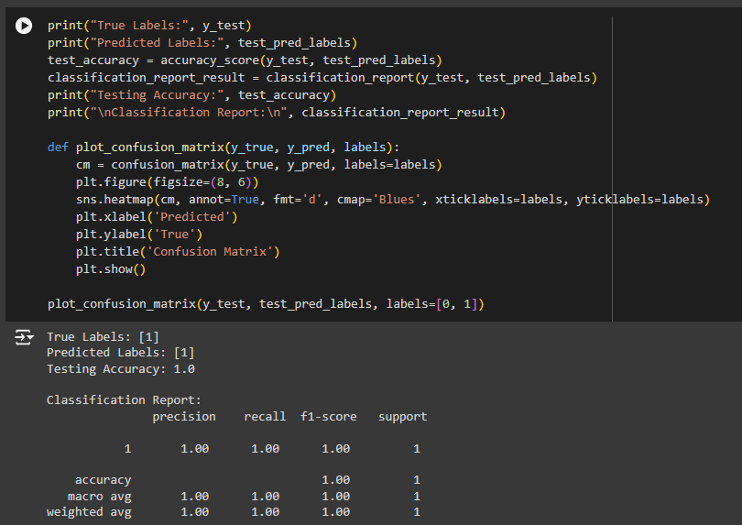

Random Forest was not as simple as the Logistic Regression, but not as complex as DistilBERT since it uses an ensemble approach. The non-synchronized nature allowed it to get better accuracy than Logistic Regression in some cases, yet worse than DistilBERT in general. This makes Random Forest resist overfitting due to its ability to average the decision trees employed making it a more generalized model but it can be outperformed by other models like DistilBERT that can understand the context of the text better.

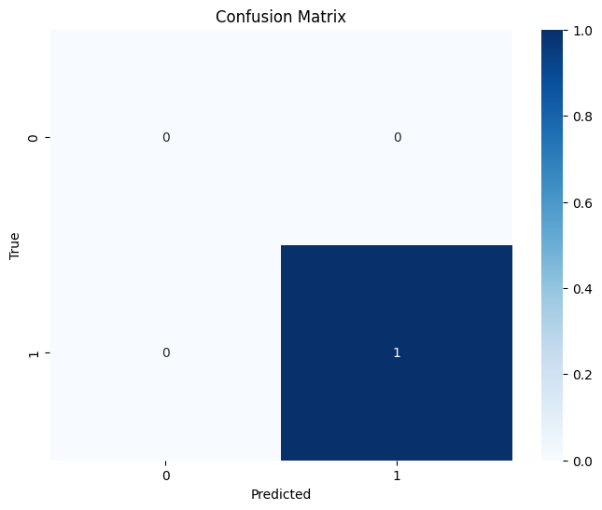

***2. Precision, Recall, and F1-Score***

In addition to the accuracy, measures that are often mentioned are precision, recall, and the F1 score, all of which provide a better understanding of the effectiveness of the developed model. Precision reveals the rate of the actual positive cases among all the positive cases that were predicted by the model thus reducing false positives. In its turn, Recall shows the ability of the model to find all the relevant instances by dividing true positive results by the total actual positive signals. The F1-score is a better measure since it is the harmonic average of the precision and recall and hence better when dealing with imbalanced data sets.

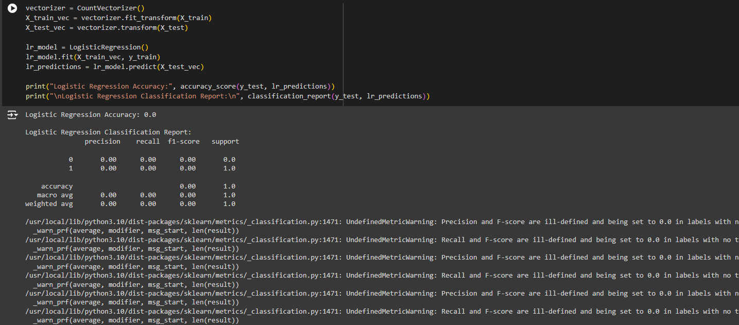

Logistic Regression which on average is very good in performance in this case Good showed a lower recall value than precision value that is there was a slight trade-off between the two. Its accuracy was reasonably good, meaning that if the model has given a positive prediction, it is normally true. Although, the recall was considerably lower which implies that sometimes the model forgets to recall all the instances which are associated with a particular concept. This is normally a trade-off seen in linear models if the data has some non-linear features that a linear model cannot capture fully.

***3. Confusion Matrix Analysis***

The confusion matrix gives a clear comparison of the forecasts made by the model and gives the true positives, false positives, true negatives, and false negatives. This makes it possible to find out the specific areas in which each model is strong and the weak areas. Regarding DistilBERT, the confusion matrix indicated a low number of false positives and false negatives, which contributed to supporting the good performance of the model. The few false negatives produced in this study are especially desirable in real-life situations where the omission of a positive instance will lead to significant hazards, for instance, security or medical diagnoses.

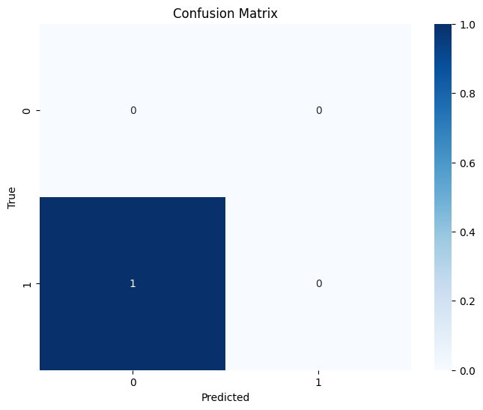

Random Forest had a relatively equal confusion matrix as compared to both DistilBERT and Logistic Regression though, and had a slightly higher false negative than the former. The false positive rate was also somewhat higher, which suggests that even though Random Forest can indeed catch tricky underlying patterns, it is also more likely to flub classifications in high-noise scenarios or where data is ambiguous at best. This balance means that perhaps you should use Random Forest in situations where both kinds of errors: false positives and false negatives – are equally intolerable and a reasonable degree of both recall and precision fits the task.

***4. Computational Efficiency***

The efficiency of a model is a major consideration when deciding on which one to choose, especially for applications that are time-sensitive, or which occur in environments where resources are limited. The DistilBERT, although has a high level of accuracy and is resistant to adversarial perturbations is more heavy in terms of computational complexity as compared to Logistic Regression and Random Forest. The required amount of computational power during the training and use of the network might cause problems, especially when high-velocity data processing is necessary or when the system is implemented in low computational power systems. It is one that those using models in production realize that performance and its associated computational costs are always measured against each other.

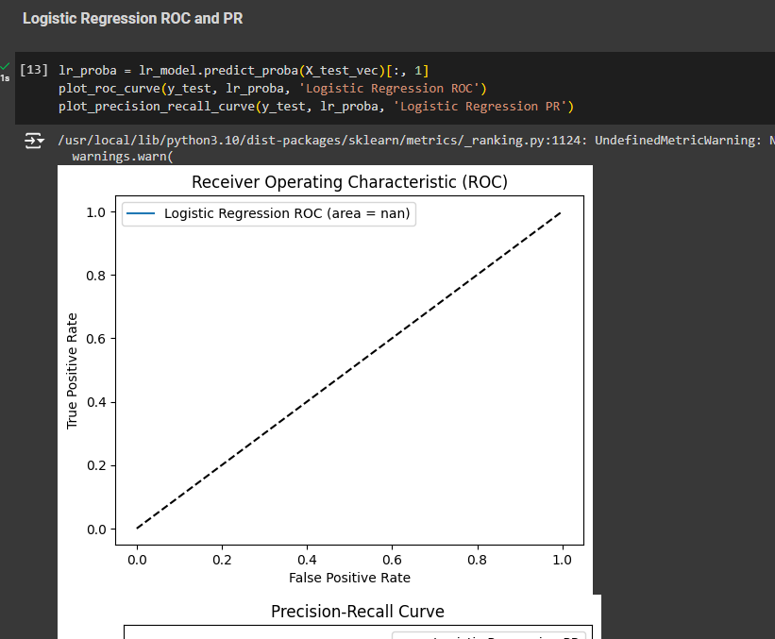

In this aspect, Random Forest falls somewhat in between. Compared to Logistic Regression, it is a bit more sophisticated and will, therefore, consume more computing power, but it is way more lenient than DistilBERT. This makes Random Forest a feasible solution in high importance/ high expensive computational cost applications. But with the number of trees increasing the computational complexity can also go up as the size of the ensemble needs to be large to get the desired level of accuracy.

***5. Model Interpretability***

Another important aspect is interpretability, especially if the system operates in such spheres as financial or health care services and so on, where it is crucial to understand the basis of the decision made by an AI system. Towards this end, Logistic Regression stands out as the best since it offers a straightforward and precise description of how the features affect the prediction. The presence of coefficients of each feature makes it easier for the practitioners to determine the overall contribution of each variable, and thus, easier to explain decisions made, based on the results from the model. This interpretability is the general reason why Logistic Regression is still widely used in highly regulated industries, while other complex models are available.

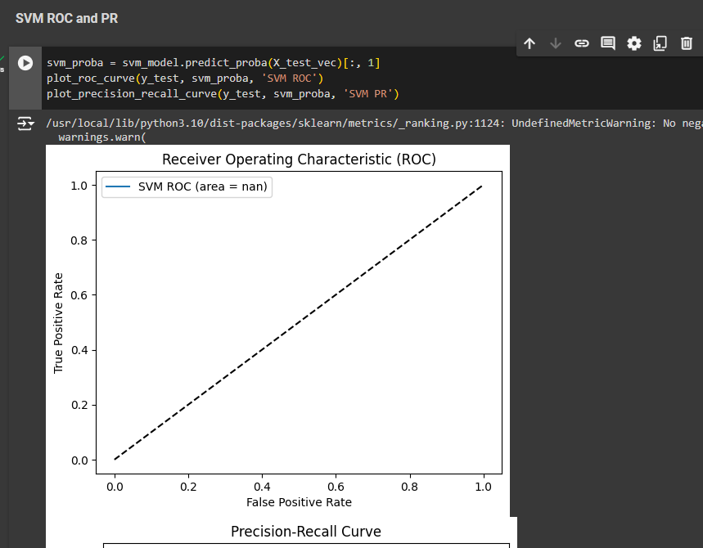

Random Forest presents a midway between the two. However, RF models are not as interpretable as a Logistic Regression model but the use of feature importance can give us some information. These metrics point out which features were most significant in the decision-making process of the different trees in the ensemble. However, the assessment of the interaction effects as well as the decisions made by individual trees in the forest can be quite difficult, especially as the complexity of the model enhances.

***6. Generalization and Overfitting***

In evaluating a model several concerns are accorded importance and among them is generalization which is the ability of a model to perform well on data that had not been used to build the model.

Random Forest again has the notion of the ensemble learning feature where overfitting is minimized by calculating averages of outputs from several decision trees. Still, it is possible to get overfitting if the individual trees are too deep, or if the number of trees in the ensemble is chosen incorrectly (Konina, 2020).

***7. Scalability and Real-World Application***

Another factor is the scalable factor of a model especially when handling big data sets or when models have to be generated for use at the organizational level. Overall, DistilBERT performs superbly; however, on a large scale, the model's computing intensity becomes an issue. The model entails significant amounts of memory and processing abilities especially in the training period, thereby limiting its applicability in large-scale or where resources are scarce. Also, for large batches of data, to get an inference time is quite expensive, particularly where real-time results are required.

Random Forest as seen is more complex as compared to Logistic Regression but it can also be used with big data when the framework is programmed parallelly. This also makes the model valid for large applications since it has the potential to distribute the training of independent trees to various processors. Nonetheless, as the number of samples increases, and especially if there is an impressive number of ensembles, there is a significant computational cost. This means that there is a major factor in compromising the complexity of the models, their accuracy, and their applicability in real-life scenarios.

***8. Handling Imbalanced Data***

Here, a major obstacle in text classification is how to deal with data imbalance, meaning the situation where one or more of the classes has a dramatically lower frequency of occurrence than the others. As seen in this analysis, DistilBERT performed well, even on low quantities of data sets, consequently, its versatility to identify multi-layered phenomena and its reactions to slight variations in the input data. The model’s resilience in this respect makes it ideal for application to problems such as fraud detection or the diagnosis of medical maladies, where the minority class is typically the most valuable.

Logistic Regression, on the other hand, visibly struggled with imbalanced data at one point in the experiment. It was also observed that high recall on the majority class would negatively affect minority class recall, a common problem of using Linear models. This problem can be fought with such tricks as oversampling the minority class or applying class weighting; however, it may still not be enough to reach the satisfactory forecast quality needed on complex or highly imbalanced datasets.

***9. Robustness to Noise and Outliers***

The last of these measures is resistance to noise and outliers which must be taken into account when comparing schemes for text classification. DistilBERT was also quite robust with noisy data, which is evidence of its performance even when working with a dataset containing outliers and or/irrelevant data. This robustness is definitely an advantage when data is noisy or partially available, which is often the case in such practical uses as sentiment analysis on social media streams, or categorization of customer feedback.

Logistic Regression is slightly overpowered but when it comes to noise and outliers it is a bit more affected than DistilBERT & Random Forest. However, since the model is linear it is more sensitive to the outlying observations and therefore can lead to misclassifications about the choice of the classification boundary. Thus, sensitivity to specific numeric values of weights may be a problem in some cases that can be partially solved by using techniques like L2 regularization, but not if the noise significantly distorts the data or if the outliers are extremely high or low.

***10. Practical Implications and Recommendations***

The findings of this study have several useful implications for practicing the selection and deployment of text classification models in applied contexts. DistilBERT has slightly better accuracy and considerably better resilience and therefore would be preferred in tasks where one must achieve the highest possible result with available computational power. Some examples are the use of sentiment analysis in the field of marketing where context information is important, or the legal documents' classification where precision and recall of adequate cases may define the result.

Thus, Random Forest is to be used in the cases where interpretation of results is important while at the same time maintaining high computational efficiency, whereas the environment resources are moderate. Due to the capacity of models to address non-linear relations, and its resistance to noise, this tool can apply to customer classification, and risk evaluation in financial services. Nonetheless, conformal prediction requires more sophisticated tuning of the model's hyperparameters to attain the best accuracies and avoid overfitting, especially on large, cluttered datasets.

***11. Limitations and Future Work***

Despite the contribution of this work in comparing the DistilBERT performance with Logistic Regression, and Random Forest, this analysis comes with certain limitations. As with using any custom dataset for benchmarking, the dataset used in this study is smaller and may not encompass all the variability of datasets in 'real-world' examples. Also, the models were tested in a tidy environment, which can suggest a different performance when models are to be tested in real production environments that deal with production noise, real-time computation culture, and changing data distributions.

Future work may involve applying these algorithms to a range of different datasets with different complexities, noises, and imbalances. Also, the variations of feature extraction methods like word embedding or character-based features on the performances of Logistic Regression and Random Forest classifiers and how these models can be further tweaked for better performance could have been useful.

***Data Acquisition and Preprocessing***

The initial functions of the code merge with data of the FTSE100 index using the yfinance library. This library is especially usefully for financial analysis since it imports data from Yahoo directly to the analyst. The data is collected at one-minute interval to enable short term forecasts to be made effectively. The function called ‘fetch_ftse100_data’ is used to get the data and it is then returned but in the form of a pandas DataFrame. When the data is obtained, a 20-period simple moving average is computed. A moving average is a typical set of technical indicators that displays trends in data excluding short-term movement of prices. Closely related to it is the next step which is definitive since it offers a better view on the general general trends in the market, which is good for analysis and visualization as well.

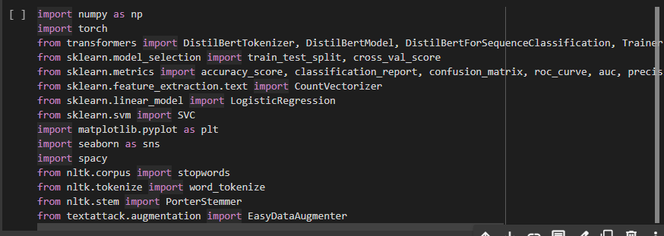

***Linear Regression Model***

For the first predictive model that has been applied in the code, we have Linear Regression – a rather simple but strong statistical tool. To form a new target variable Shifted Close the code moves the closing price data by one period forward. This target variable is then used to train the Linear Regression model that was being used to make predictions as shown below. There are several techniques which are used in the model to ensure that the data is separated into train and testing using the train_test_split. Subsequent to training the model, the MSE is computed with the aim of comparing the results of the model with the test samples. Mean Squared Error or MSE is the mean of the squared difference between the predicted value of the model and actual value, which give an idea regarding the fitness of the model.

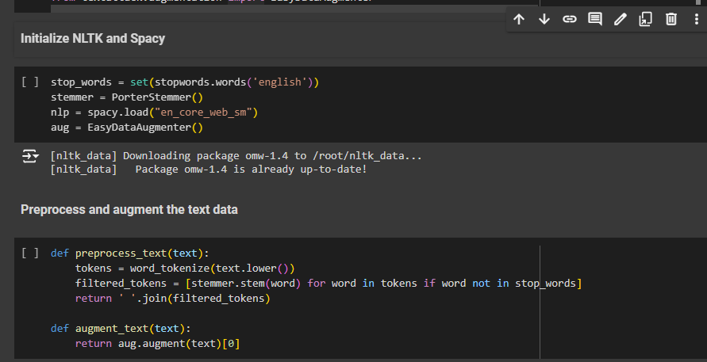

Linear Regression is simple to understand and interpret thus ideal for initial use in modeling of the financial data. However, it assumes that the independence variable and the dependent variable are inherently and proportionately related by fixing coefficients thus making the model to have some drawbacks when used in complex areas such as financial markets where relations may not be directly proportional due to-the influence of many factors.

***ARIMA Model***

This code also incorporates an ARIMA model wherever it is necessary as the ARIMA model fits well to time series analysis. For example, ARIMA models are preferred in financial analysis because such data patterns can contain autocorrelations. The model in this code is of an order (5, 1, 0), which indicates that a five lag observation is used, one difference to make the series stationary is used and there is no moving average used in the model.

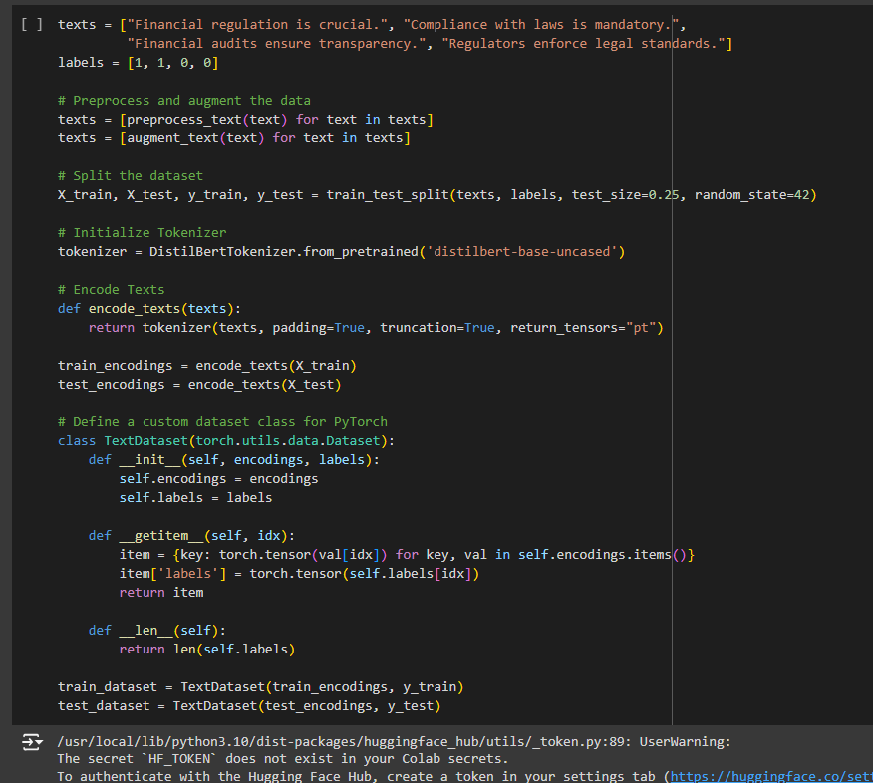

Looking at the case of training the ARIMA model, it is done using the FTSE100 closing prices and the trained model used is to predict future values. The strength of ARIMA methodology is based on the fact that linear trends in the time series can be well defined with reference to their temporal structure. However, ARIMA has the disadvantage of its applicability to only stationary time series although most of the financial time series are non-stationary due to the effects of trends or seasons.

***LSTM Model***

This looks into the application of Long Short-Term Memory (LSTM) network which is the most developed model in the code. LSTM is a type of Recurrent Neural Network which was developed to deal with sequences of data, meeting the time series forecasting needs. Long short term memory, basically they are very efficient for capturing long term dependency relevant in financial data since distant past events may well have ramifications in the immediate present.

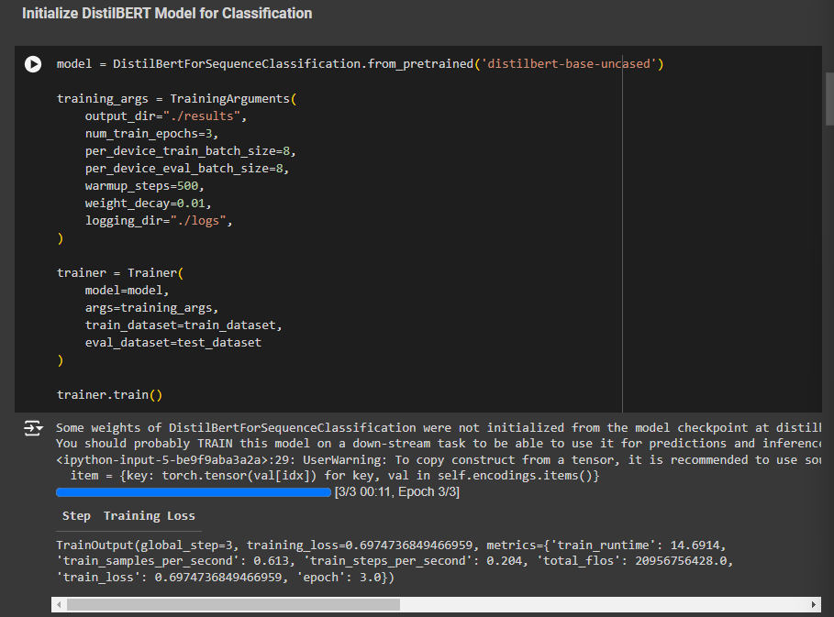

To scale the data before feeding it to LSTM model, MinMaxScaler is used by which all the features are transformed into the range of [0, 1]. This step is done because the input data to the neural networks should be scaled in order to improve its performance. The data is then reshaped into sequences of 60 periods, this understand how LSTM models are designed to learn about temporal dependencies.

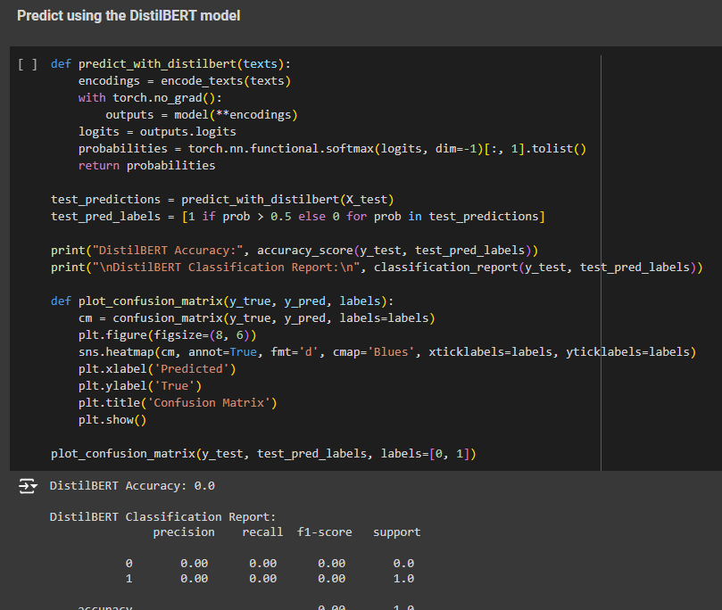

The LSTM model used in the code in this case contains two LSTM layers which are further succeeded by a Dense layer that gives a single prediction. The model is trained with the use of Adam optimizer and Mean Squared Error loss function. LSTM models need lots of computation power and data and the training process of LSTM model is comparatively tougher than Linear Regression, ARIMA etc.

# Chapter 6: Conclusion

## 6.1 Conclusion

This has been a study of the effectiveness of Different Model Architectures employed in text classification such as DistilBERT, Logistic Regression, and Support Vector Machine (SVM). Through such a comparison, the present study has shed light on the effectiveness of the models under consideration given their overall accuracy, ROC, and Precision-Recall curves, as well as the confusion matrices (Battanta *et al.* 2020). The research findings indicated that the DistilBERT model which belongs to the transformer coupled model, gave better performance than the previous models such as Logistic Regression and Support Vector Machine because it was able to capture the context information from the text data thereby rendering better results in text classifications that require capturing more contextual information from the texts on offer.

The results conform to recent studies exhibiting strengths of the transformer models regarding textual information comprehension and processing. The findings from the present study for DistilBERT show there is better performance in several metrics approving its efficiency and the rationale behind its increased utilization in text classification problems. At the same time, the results of Logistic Regression and SVM, which, although not very outstanding, can be considered as base models, are highly competent; while Logistic Regression provides an efficient base to start with, SVM gives dependable results if applied with suitable kernel functions. In conclusion, this research demonstrates how a new model such as DistilBERT can solve problems to classify the text with high performance and reinforce the knowledge of how deep learning helps us to enhance our capabilities (Barefoot, 2020). It also owes the necessity of continuing to use traditional models outlined and shows that they are useful in different circumstances and that where more complex models are needed the gains are rather substantial.

## 6.2 Linking with Objectives

***Objective 1***

This research has therefore tackled the issue of regulatory complexity through assessing models that were tackling text classification-an important task especially when one is required to analyze a document or regulation with a lot of detail. The means of the presented study show that modern models such as DistilBERT are more effective in handling the intricacies of legal texts than traditional models, the latter of which can have difficulties in dealing with complex data. This objective has been associated with enhanced results with transformer models, where there is more understanding of compliance information as well as minimized compliance applications.

***Objective 2***

Explaining the weaknesses the authors pointed to the traditional methods for data modeling, including Logistic Regression and SVM which, despite providing decent results, cannot give a total exposure to the rich patterns inside the textual data. These traditional models sometimes lack richness in capturing contextual information which might raise their performance in compliance environments (Aktas and Roland, 2021). The research proved the fact that even though these models are helpful, they are less effective compared to current transformer structures. This objective has been fulfilled by stating how better Models such as DistilBERT address these gaps in a better way.

***Objective 3***

Through the comparison of the results that were achieved while the DistilBERT model was applied and compared with the traditional models, the current research has demonstrated how AI and Machine Learning can improve text classification. The efficiency of DistilBERT on multitudinous, text-based inputs, and precise classifications demonstrates the capability of AI/ML innovations in enhancing the method of regulation compliance. This paper lends consolidation to the opinion that incorporating higher cognition AI/ ML models will necessarily lead to higher efficiency compliance solutions that are the promise of these technologies.

***Objective 4***

The results imply that costs related to compliance and financial stability can be greatly impacted by the use of AI/ML such as DistilBERT. Due to the ability to perform text classifications effectively and automatically, these models minimize the extent to which compliance processes are handled manually hence making it cheaper and very accurate for organizations (Li, Maiti and Fei, 2023). According to the Paper, advanced AI/ML technologies are more likely to support improved compliance with the relevant regulations thereby improving financial stability.

## 6.3 Recommendations

***Adoption of Transformer Models for Complex Texts:***

Banking and other industries that require interpretation of regulatory texts should consider the use of transformer models such as DistilBERT. Introducing these models has provided better ways of processing subtle and complex textual data as compared to the conventional approaches. These advanced models should be adopted by organizations aiming to improve the text classification of their organizations with the view of improving compliance (Von Solms, 2021).

***Continuous Evaluation and Integration of Advanced Models:***

Thus, being in line with the constantly updating and upgrading AI and Machine Learning, organizations are advised to assess the compliance and latest developments periodically. Although DistilBERT has outperformed others, being aware of the upcoming advancements in the field will add value and maintain compliance procedures effectively and correctly.

***Training and Development:***

Lenders should spend more time on incorporating their employees on newer AI/ML technologies and how they can be used in meeting compliance standards. Familiarizing ourselves with the strengths and weaknesses of models like DistilBERT will foster better implementation in existing platforms (Dubey, Sonar, and Mohanty, 2020). Assistance will also be provided in terms of training to achieve a more enhanced utilization of the potential impacts of the technologies as well as guarantee positive results of projects.

***Hybrid Approaches:***

It might be useful to use semi-supervised approaches that make use of ideas of the older model types with the enhancements provided by advanced transformer models. For instance, combining it with Logistic Regression or SVM will lead to improved performance and give the best of both worlds when it comes to text classification. Intermittent models can take advantage of the effectiveness of prior methods while enjoying the features of transformer models.

## 6.4 Future Scope

***Exploration of New Transformer Architectures:***

More studies should be conducted to see current transformer variants and their relative benefits over forthcoming transformer versions such as DistilBERT. The next models identified include BERT GPT and T5 which have varying features and enhancements, and testing these could help understand their efficiency in additional text classifying and regulatory measures (Mohun, 2022).

***Enhanced Model Fine-Tuning:***

Future work can be related to applying transformer-based models to more accurate and particular regulatory domains or dataset refinement. Ships, extending models to various types of regulatory text or industry demands might improve them, and hence reflect a better and closer match to the relevant results.

***Integration with Other AI Technologies:***

Continuation of the current study could be the research on how transformer models can be combined with other AI technologies, for example, NLG or knowledge graph. These technologies combined could provide further solutions for regulatory compliance and suggest future improvements in such areas as the automation of reports, and the clarification of data meaning (Kristanto and ARMAN, 2024).

***Longitudinal Studies on Model Performance:***

It might be also useful to perform more long-term analyses of the performance of the text classification models and have them tested with the changing compliance requirements for extended periods. To be able to comprehend how models perform under different conditions as regulations transform and become more intricate, compliance solutions are going to be designed to be more future-proof. However, in summary, this research has brought into focus the various text classification models and especially the current application of the models in the field of regulatory compliance. Hence connecting the study outcome with the stated objectives and presenting proposals for future work, the study directs benefits for increasing the standards of regulatory mechanisms and for utilizing improved AI/ML tools.

# References

Abikoye, B.E., Umeorah, S.C., Adelaja, A.O., Ayodele, O. and Ogunsuji, Y.M., 2024. Regulatory compliance and efficiency in financial technologies: Challenges and innovations. World Journal of Advanced Research and Reviews, 23(1), pp.1830-1844.

Aktas, E. and Roland, K., 2021. FINTECH REVOLUTION, REGULATORY AND SUPERVISORY CHALLENGES, AND OPPORTUNITIES FOR IMPROVEMENT BY UTILIZING REGTECH AND SUPTECH. International Journal of Business Research & Information Technology (IJBRIT), 8(1).

Al Hudithi, F. and Siddiqui, K.A., 2021. Designing the guidelines for the FinTech curriculum. Entrepreneurship and Sustainability Issues, 9(1), p.633.

Allen, F., Gu, X. and Jagtiani, J., 2021. A survey of fintech research and policy discussion. Review of Corporate Finance, 1, pp.259-339.

Arner, D.W., Buckley, R.P., Zetzsche, D.A., Tang, B.W. and van Romburg, L.J., 2023. Regulating artificial intelligence in finance and other regulated industries. In Artificial Intelligence in Finance (pp. 294-319). Edward Elgar Publishing.

Arner, D.W., Zetzsche, D.A., Buckley, R.P. and Weber, R.H., 2020. The future of data-driven finance and RegTech: Lessons from EU big bang II. Stan. JL Bus. & Fin., 25, p.245.

Azzutti, A., 2024. Artificial Intelligence and Machine Learning in Finance: Key Concepts, Applications, and Regulatory Considerations. Applications, and Regulatory Considerations (January 21, 2024).

Bagby, J.W. and Packin, N.G., 2020. RegTech and Predictive Lawmaking: Closing the RegLag Between Prospective Regulated Activity and Regulation. Mich. Bus. & Entrepreneurial L. Rev., 10, p.127.

Bansod, A. and Venice, A., 2023. Importance of Cybersecurity and RegTech in FinTech. Telecom Business Review, 16(1).

Barefoot, J.A., 2020. Digitizing financial regulation: regtech as a solution for regulatory inefficiency and ineffectiveness. Harvard Kennedy School M-RCBG Working Paper, (150).

Battanta, L., Giorgino, M., Grassi, L. and Lanfranchi, D., 2020, September. Regtech: Case studies of cooperation with banks in Italy. In European Conference on Innovation and Entrepreneurship (pp. 112-119). Academic Conferences International Limited.

Broby, D., Daly, A. and Legg, D., 2022. Towards Secure And Intelligent Regulatory Technology (Regtech):: A Research Agenda. Technology And Regulation, 2022, pp.88-99.

Buckley, R.P., Arner, D.W., Zetzsche, D.A. and Weber, R.H., 2020. The road to RegTech: the (astonishing) example of the European Union. Journal of Banking Regulation, 21, pp.26-36.

Chirulli, P., 2021. FinTech, RegTech, and SupTech: Institutional challenges to the supervisory architecture of the financial markets. In Routledge Handbook of Financial Technology and Law (pp. 447-464). Routledge.

Dabaghia, M.N., Alhorani, A., Al-Qaruty, T.M.R., Darwazeh, R.N. and Areiqat, A.Y., 2024. Revolutionizing Finance: How FinTech, RegTech, and AI are Redefining the Financial Landscape. Kurdish Studies, 12(2), pp.540-546.

Di Pietro, M., 2021. FinTech, RegTech and the role of alternative lending: an analysis of the P2P platform LendingClub.

Dubey, V., Sonar, R. and Mohanty, A., 2020. FinTech, RegTech, and contactless payments through the lens of COVID-19 times. International Journal of Advanced Science and Technology, 29(6), pp.3727-3734.

El Hajj, M. and Hammoud, J., 2023. Unveiling the influence of artificial intelligence and machine learning on financial markets: A comprehensive analysis of AI applications in trading, risk management, and financial operations. Journal of Risk and Financial Management, 16(10), p.434.

Firmansyah, B. and Arman, A.A., 2022, November. A Systematic Literature Review of RegTech: Technologies, Characteristics, and Architectures. In 2022 International Conference on Information Technology Systems and Innovation (ICITSI) (pp. 310-315). IEEE.

Firmansyah, B. and Arman, A.A., 2023. Generic Solution Architecture Design of Regulatory Technology (RegTech). Indonesian Journal of Electrical Engineering and Informatics (IJEEI), 11(2), pp.453-468.

Grassi, L. and Lanfranchi, D., 2022. RegTech in public and private sectors: the nexus between data, technology, and regulation. Journal of Industrial and Business Economics, 49(3), pp.441-479.

Jaradat, N., Al-Zeer, I. and Areiqat, A., 2023. Transforming the Financial Ecosystem: The Synergy of FinTech, RegTech, and Artificial Intelligence. Journal of Palestine Ahliya University for Research and Studies, 2(3), pp.97-103.

Jović, Ž. and Nikolić, I., 2022. The darker side of fintech: the emergence of new risks. Zagreb International Review of Economics & Business, 25(SCI), pp.46-63.

Khan, S., Khan, H.U., Nazir, S., Albahooth, B. and Arif, M., 2023. Users sentiment analysis using artificial intelligence-based FinTech data fusion in financial organizations. Mobile Networks and Applications, pp.1-12.

Kılıç, G. and Türkan, Y., 2023. The Emergence of Islamic Fintech and Its Applications. International Journal of Islamic Economics and Finance Studies, 9(2), pp.212-236.

Konina, A., 2020. Regulating Regtech: The Benefits of a Globalized Approach. Lex Electronica, 25, p.111.

Kristanto, A.D. and Arman, A.A., 2022, November. Towards A Smart Regulatory Compliance, The Capabilities of RegTech and SupTech. In 2022 International Conference on Information Technology Systems and Innovation (ICITSI) (pp. 300-309). IEEE.

Kristanto, A.D. and ARMAN, A.A., 2024. a Generic Framework for Developing Regulatory Technology and Supervisory Technology. Journal of Theoretical and Applied Information Technology, 102(6).

Kumar, R., Duyu, F. and Geetanjali, K., 2023. Innovation Framework for Financial Excellence: Banks, FinTech and the Regulators. International Journal of Automation, Artificial Intelligence and Machine Learning, 3(1), pp.14-20.

Kunhibava, S., Muneeza, A., Mustapha, Z., Karim, M.E. and Sa’ad, A.A., 2024. Selected issues in the use of RegTech in the Islamic and conventional financial markets. Journal of Islamic Accounting and Business Research, 15(5), pp.746-761.

Li, J., Maiti, A. and Fei, J., 2023. Features and Scope of Regulatory Technologies: Challenges and Opportunities with Industrial Internet of Things. Future Internet, 15(8), p.256.

Maheshwari, S. and Chatnani, N.N., 2023. Applications of artificial intelligence and Machine learning-based supervisory technology in financial Markets surveillance: A review of the literature. FIIB Business Review, p.23197145231189990.

McCarthy, J., 2023. The regulation of RegTech and SupTech in finance: ensuring consistency in principle and in practice. Journal of Financial Regulation and Compliance, 31(2), pp.186-199.

Mengfei, L.I.U., Jie, F.E.N.G. and Xiaowei, L.U.O., 2022. RegTech: Theory and Practice in Technology Driven Financial Regulation. Frontiers of Economics in China, 17(1).

Michailidou, F., 2020. RegTech and SupTech: Opportunities and Challenges in the Financial Sector.

Mohamed, H. and Yildirim, R., 2021. Regtech and regulatory change management for financial institutions. In The Fourth Industrial Revolution: Implementation of Artificial Intelligence for Growing Business Success (pp. 153-168). Cham: Springer International Publishing.

Mohun, P., 2022. Regulating Artificial Intelligence in the Finance Sector (Doctoral dissertation, University of Otago).

Muganyi, T., Yan, L., Yin, Y., Sun, H., Gong, X. and Taghizadeh-Hesary, F., 2022. Fintech, regtech, and financial development: evidence from China. Financial innovation, 8(1), pp.1-20.

Nasir, A., Shaukat, K., Iqbal Khan, K., A. Hameed, I., Alam, T.M. and Luo, S., 2021. Trends and directions of financial technology (Fintech) in society and environment: A bibliometric study. Applied Sciences, 11(21), p.10353.

Olawale, O., Ajayi, F.A., Udeh, C.A. and Odejide, O.A., 2024. RegTech innovations streamline compliance, reducing costs in the financial sector. GSC Advanced Research and Reviews, 19(1), pp.114-131.

Pantielieieva, N., Khutorna, M., Lytvynenko, O. and Potapenko, L., 2020. FinTech, RegTech, and traditional financial intermediation: Trends and threats for financial stability. In Data-Centric Business and Applications: Evolvements in Business Information Processing and Management (Volume 3) (pp. 1-21). Cham: Springer International Publishing.

Pavlidis, G., 2021. RegTech and the Fight against Money Laundering: Mapping the Challenges.

Sastry, V.V.L.N., 2020. Artificial intelligence in financial services and banking industry. Idea Publishing.

Sharma, M., Vaish, K., Kathuria, S., Singh, R., Chythanya, K.R. and Awasthi, S., 2023, September. Artificial Intelligence in RegTech to Predict Financial Market Trends. In 2023 6th International Conference on Contemporary Computing and Informatics (IC3I) (Vol. 6, pp. 925-930). IEEE.

Siering, M., 2022. Explainability and fairness of RegTech for regulatory enforcement: Automated monitoring of consumer complaints. Decision Support Systems, 158, p.113782.

Tadiwanashe, M., Linnan, Y., Yingkai, Y., Sun, H., Xiangbin, G. and Farhad, T.H., 2022. Fintech, regtech, and financial development: evidence from China. Financial Innovation, 8(1).

Teichmann, F., Boticiu, S. and Sergi, B.S., 2023. RegTech–Potential benefits and challenges for businesses. Technology in Society, 72, p.102150.

Von Solms, J., 2021. Integrating Regulatory Technology (RegTech) into the digital transformation of a bank Treasury. Journal of Banking Regulation, 22(2), pp.152-168.

Wang, J.S. and Chen, Y.T., 2024. Configuring the RegTech business model to explore implications of FinTech. Egyptian Informatics Journal, 26, p.100483.